**Assignment Name**: **Lab8:** (**C++ File Processing)**

**Due date:** **11/2/2022, by 11:00 am.**

**Grade for assignment: 20** points

**Purpose:** Obtain experience in receiving input and output from a file. Assignment accomplishes course learning objective “Compile, execute, and run simple programs (in C++)”. Assignment also provides preparation for COSC236 course, and enhances skills needed in Information Technology (IT) and Computer Science industries.

**Skills:** Purpose of assignment is to help you practice the following skills.

-Ability to read data from a file, as input

-Ability to write data to a file, as output

**Knowledge:** Become familiar with how files can be used in computer programs.

**\*\*\*\*\*\*\*\*\*\*\*\*\*\*\*\*\*\*\*\*\*\*\*\*\*\*\*\*\*\*\*\*\*\*\*\*\*\*\*\*\*\*\*\*\*\*\*\*\*\*\*\*\*\*\*\*\*\*\*\*\*\*\*\*\*\*\*\*\*\*\*\*\*\*\*\***

**Place your Name(s) below:**

**Pairs work:** Please work in pairs. **One student in team should submit work**. Put **your first and last name on the assignment** and **your partner’s first and last name on the** assignment

**Note(s):**

1. All programs should be completed within the Visual Studio Code environment. There are guides in blackboard to start you off with Visual Studio Code.

**Partner 1: Name** Blessing Abumere

**role (did the typing or read and review) _____________________________**

**Partner 2: Name ______________________________________________**

**role (did the typing or read and review)______________________________**

**Please note if one partner did not work on all problems.**

**Submission instructions:** All submissions will be done using blackboard. **Answers are to be submitted in a Microsoft word document.**

**Task**:

**Examples:** Refer to your notes from class, the Files PowerPoint, Loops (Part4) PowerPoint, in class exercises and any available videos (all located in Blackboard).

**Part1 (10 Points):**

1. Create a text file in notepad, and name it **testFile1.txt** and save this file on your “H” drive.
2. Type the following data (98 100 58 70 75 80 85 90 60 65) into **testFile1.txt** (see Sample below)

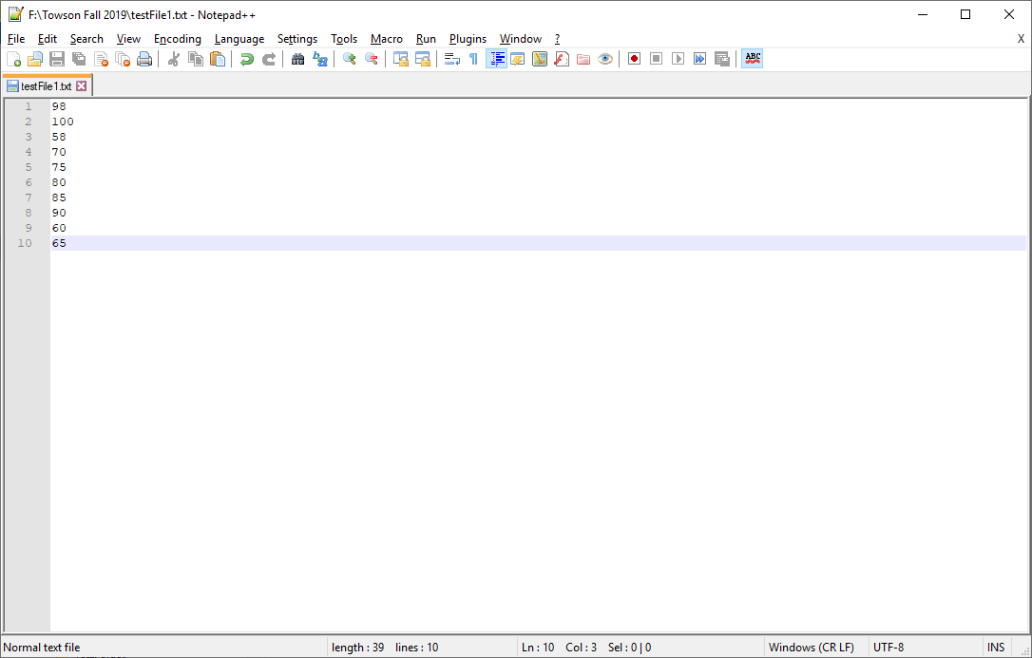

1. Locate the file path of **testFile1.txt** on your “H” drive; and write down your file path.
2. Type in the following program. Add a comment at the top to include your name(s) and the date. And **Change the file path in the program**, to be the file path from step 3 above; (Note: Remember to use double back slashes **\\**)

#include <iostream>

#include <string>

#include <fstream> // includes ifstream and ofstream

using namespace std;

int main()

{

int total;

int temp;

temp = 0;

total = 0;

// declare a handle

ifstream infile; // open only

//Open the file

infile.open("f:\\Towson Fall 2019\\testFile1.txt");

//outFile is associated with stuff

//prime read

infile >> temp;

while (infile)

{

total = total + temp;

infile >> temp;

}

cout <<"The total of all temperatures is " << total << endl;

return 0;

}

 -Compile and Run.

1. This is an example of reading a file.

d) **SUBMIT your corrected code, and sample of output (Below):**

/*

    Blessing Abumere

    COSC 175

    10/26/2022

*/

#include <iostream>

#include <string>

#include <fstream> // includes ifstream and ofstream

using namespace std;

int main()

{

    int total;

    int temp;

    temp = 0;

    total = 0;

    // declare a handle

    ifstream infile; // open only

    //Open the file

    infile.open("H:\\testFile1.txt");

    //outFile is associated with stuff

    //prime read

    infile >> temp;

    while (infile)

    {

        total = total + temp;

        infile >> temp;

    }

    cout <<"The total of all temperatures is " << total << endl;

    return 0;

}

**Part2 (10 Points):**

1. Create a text file in notepad, and name it **stuff.txt** and save this file on your “H” drive. (see Sample below) [Note: creating text file is optional for this type of program]

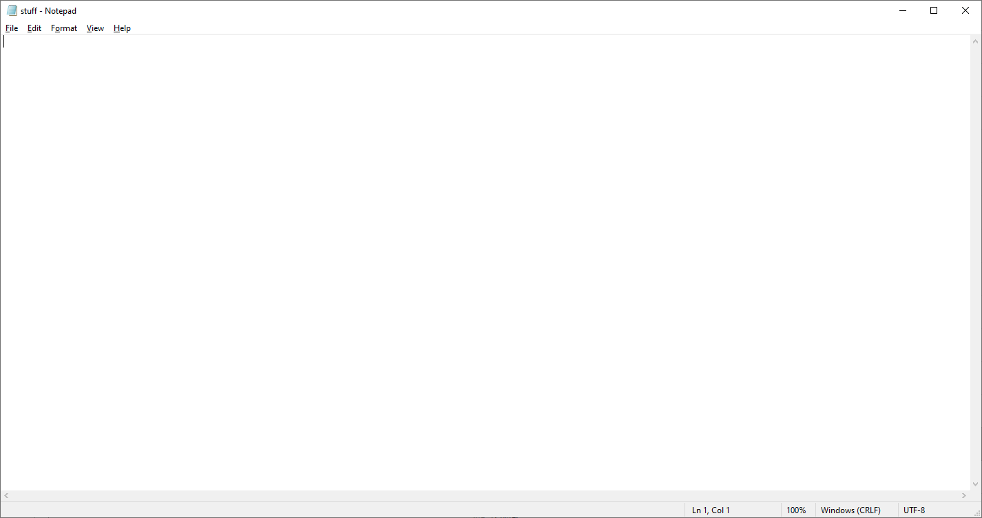

1. Locate the file path of **stuff.txt** on your “H” drive; and write down your file path.
2. Type in the following program. Add a comment at the top to include your name(s) and the date. And **Change the file path in the program**, to be the file path from step 2 above; (Note: Remember to use double back slashes **\\**)

#include <iostream>

#include <fstream> // includes ifstream and ofstream

using namespace std;

int main()

{

// declare a handle

ofstream outFile; // open only (writing)

//Open the file

outFile.open("f:\\Towson Fall 2019\\stuff.txt");

//outFile is associated with stuff

//Write to file

outFile << "Hello" << endl;

return 0;

}

 -Compile and Run.

1. This is an example of writing a file.
2. **SUBMIT your corrected code, and sample of output (Below):**
3. /*
4. Blessing Abumere
5. COSC 175
6. 10/26/2022
7. */
8. #include <iostream>
9. #include <fstream> // includes ifstream and ofstream
10. using namespace std;
11. int main()
12. {
13. // declare a handle
14. ofstream outFile; // open only (writing)
15. //Open the file
16. outFile.open("H:\\stuff.txt");
17. //outFile is associated with stuff
18. //Write to file
19. outFile << "Hello" << endl ;

22. return 0;
23. }

**\*\*\*\*\*\*\*\*\*\*\*\*\*\*\*\*\*\*\*\*\*\*\*\*\*\*\*\*\*\*\*\*\*\*\*\*\*\*\*\*\*\*\*\*\*\*\*\*\*\*\*\*\*\*\*\*\*\*\*\*\*\*\*\*\*\*\*\*\*\*\*\*\*\*\*\*\***

**Criteria for Success**:

**a**) Be sure to submit your code and output above for each question; **Submission of Code and output is required**. (Note: use screen shots or copy and paste).

For example if the assignment was to write a program that displays “Hello World”

Your **code** would be as follows:

//Lab1 answer COSC175002

#include <iostream>

using namespace std;

int main()

{

cout << "Hello, world" << endl;

system("pause");

} // end of main

Your **output** would be as follows:

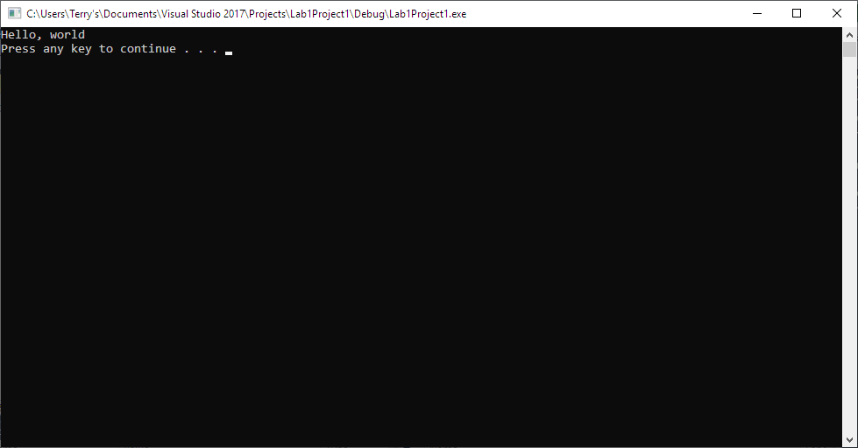

Note: To avoid additional point deductions; remember to submit both code and output.

>>>

**b)** Be sure to show completion of Security Injections by providing Screen shots of (or copy and paste) your Security Injection completion **Certificate** above**. Do not email me your certificate.**

**c) Late policy:** Late submissions will receive a zero grade. Get help during the week so that you can submit on time.